UNIVERSITY

SCHOOL VANDALISM IN MALAWI – VOICES OF EDUCATORS ON PREVENTION MEASURES

BY
Your

(student id number)

Name of Lecture:

SUBMISSION DATE
APRIL, 2024

Table of Contents
CHAPTER ONE: INTRODUCTION 4
1.0 Introduction 4
1.1 Background Information 4
1.2 Statement of the Problem 5
1.3 Main Objective 5
1.3.1 Specific objectives 6
1.3.2 Research Questions 6
1.4 Significance of the Study 6
1.6 Delimitation of the Study 6
CHAPTER TWO : LITERATURE REVIEW 7
2.1 Introduction 7
2.2 Theoretical Framework 7
2.2.1 Bronfenbrenner’s Ecological Systems Theory 7
2.2.2 Theory of Planned Behavior 8
2.3 Empirical Review 8
2.3.1 Strategies Currently Used to Prevent Vandalism 8
2.3.2 Challenges in Implementing Prevention Measures 9
2.3.3 Perceptions of Effective Approaches for Reducing Vandalism 9
2.3.4 Key Gap Identified in the Literature 10
CHAPTER THREE: RESEARCH METHODOLOGY 11
3.1 Introduction 11
3.2 Study Area 11
3.3 Research Paradigm 11
3.4 Research Approach and design 11
3.5 Study Population and Sample Size 12
3.6 Sampling Techniques 12
3.7 Trustworthiness 12
3.8 Data Collection 12
3.9 Data Analysis 13
3.10 Ethical Considerations 13
3.11 Methodology matrix 13
3.12 Summary of the Chapter 15
CHAPTER FOUR: RESULTS AND FINDINGS 16
4.1 Introduction 16
4.2. Details of the respondents 16
4.2.1 Gender Distribution 16
4.2.2 Position/Role of Respondents 16
4.2.3 Years of Experience in Education 17
4.2.4 Type of School 18
4.2.5 School Location 18
4.3 Strategies Used to Prevent Vandalism 19
4.2 To assess the challenges educators face in implementing vandalism prevention measures. 20
4.4 To examine educators` perceptions on effective approaches for reducing school vandalism. 21
CHAPTER FIVE: DISCUSSION OF RESULTS 23
5.1 Introduction 23
5.2 Strategies Used to Prevent Vandalism 23
5.3 Challenges in Implementing Vandalism Prevention Measures 24
5.4 Educators’ Perceptions of Effective Approaches 24
5.5 Conclusion 25
CHAPTER SIX: SUMMARY, CONCLUSION, LIMITATIONS, AND RECOMMENDATIONS 26
6.1 Summary of the Study 26
6.2 Conclusion 26
6.3 Limitations of the Study 26
6.4 Recommendations 27
6.5 Areas for Further Study 27
References 28

CHAPTER ONE: INTRODUCTION

Introduction
School vandalism remains a persistent challenge in Malawian secondary schools, undermining safe learning environments, damaging infrastructure, and diverting scarce educational resources. Despite policy responses and disciplinary frameworks, incidents of property destruction continue, suggesting gaps between strategy and practice. This study examines school vandalism through the voices of educators, who are directly responsible for prevention and response. The thesis of this study is that effective prevention of school vandalism in Malawi requires integrated, educator-informed approaches that combine discipline, student engagement, community participation, and structural support.

1.1 Background Information
School vandalism, defined as the intentional destruction or defacement of school property remains a persistent and serious threat to safe learning environments in Malawi. Recent stutdies show that vandalism in schools often involves the breaking of windows, desks, doors, and classroom blocks, resulting in major financial losses and disruptions to teaching and learning (Phiri & Banda, 2017). High-profile cases, such as the burning of thousands of textbooks and destruction of newly constructed school facilities in districts like Mchinji, demonstrate the severity of this behaviour (Chirwa, 2019). These incidents not only interrupt learning but also lower morale among teachers and students and weaken school community relationships.
The causes of vandalism are complex and influenced by multiple factors. Contemporary research indicates that peer pressure, weak school discipline systems, poor management, and student disengagement are common drivers of destructive behaviour (Maphosa & Bhebhe, 2019). Studies further show that students who feel alienated or unfairly treated within the school system are more likely to participate in vandalism (Nemlioğlu & Atak, 2010a; Mutiso & Njoroge, 2018). In Malawi, challenges such as poor school infrastructure, limited supervision, and wider societal influences—including community conflicts and youth delinquency have also been linked to increased cases of vandalism (Musaya, 2022). In response, policymakers and community leaders have advocated for stronger disciplinary measures, improved parental involvement, and collaboration with religious and traditional leaders to instill respect for school property.
Despite the scale of the problem, there remains a notable research gap, especially regarding the perspectives of educators who directly experience and manage vandalism-related challenges. Teachers and school administrators hold critical insights into learner behaviour, school culture, and community dynamics, yet their voices are often missing in studies on school vandalism (Kaunda, 2020). Without incorporating these perspectives, interventions risk being generalized and ineffective in addressing local realities.
This study aims to fill this gap by exploring educators’ views on the causes and effects of school vandalism in Malawi. By drawing on their professional experiences, the research seeks to generate practical and context-specific recommendations that can inform effective prevention strategies. Ultimately, the findings are expected to support efforts to reduce vandalism, protect educational resources, and enable schools to concentrate on their core mission of teaching and learning.

1.2 Statement of the Problem
School vandalism remains a pressing issue in Malawi, causing significant financial losses and disrupting the learning environment (Mtaita, 2022). Despite its prevalence, there's limited research on the underlying causes and effective prevention strategies, highlighting a critical knowledge gap (Kachapila, 2021). Many schools face repeated destruction, yet the views of teachers, head teachers, and education officers are often overlooked in decision-making and policy development. Engaging educators in this process is crucial for developing contextually relevant solutions (Chirwa, 2023). However, their voices are often overlooked in decision-making processes, resulting in a gap between policy and practice. This study aims to bridge this gap by capturing educators' perspectives on vandalism causes and potential solutions, ultimately promoting safer learning environments. By exploring educators' experiences and ideas, this research seeks to inform effective prevention strategies and foster a supportive learning environment in Malawian schools. The findings will contribute to addressing the persistent challenge of school vandalism.

1.3 Main Objective
The main objective of this study is to explore educators' perspectives on the causes of school vandalism and potential solutions, capturing their experiences and ideas for prevention and mitigation to promote a safer and more supportive learning environment in Malawian schools.

1.3.1 Specific objectives
- To explore the strategies currently used by schools to prevent to vandalism
- To assess the challenges educators face in implementing vandalism prevention measures.
- To examine educators` perceptions on effective approaches for reducing school vandalism.

1.3.2 Research Questions
- 1. What are the current strategies used by schools to prevent vandalism?
- 2. What are the challenges educators face in implementing vandalism prevention measures?
- 3. What is the perception of educators on effective approaches for reducing school vandalism?

1.4 Significance of the Study
This study holds critical significance for policy, theory, and practice in Malawian education. For policy, it provides evidence-based recommendations to inform national strategies on school safety and resource protection. Theoretically, it enriches global discourse by contextualizing vandalism within Malawi's socio-economic landscape through educators' lived experiences. Practically, it equips school leaders and communities with actionable, context-specific prevention measures to safeguard educational infrastructure and foster resilient learning environments.

1.6 Delimitation of the Study
This study is delimited to exploring the causes and prevention of school vandalism from the professional perspectives of secondary school educators in the Central Region of Malawi. It specifically investigates acts of intentional damage to institutional property, such as infrastructure and learning materials. The research focuses on the insights of teachers and administrators, rather than students or community members, and employs a qualitative case study design. Consequently, the findings are context-specific and not intended for broad statistical generalization to all settings (Chile & Black, 2020).

CHAPTER TWO : LITERATURE REVIEW

2.1 Introduction
This literature review is structured to critically examine existing scholarly work on school vandalism, with a specific focus on aligning with and contextualizing the objectives of this study. It seeks to establish a foundation by exploring the global, regional, and local discourse on the prevention of school vandalism, the strategies employed, the challenges encountered, and the perceptions of effective approaches. The aim is to synthesize this knowledge to clarify the research terrain and explicitly identify the gap that this study centered on the perspectives of Malawian educators intends to fill.

2.2 Theoretical Framework
This study is informed by two complementary theoretical frameworks. First, Bronfenbrenner’s Ecological Systems Theory, as articulated in later works, provides good method to analyze how vandalism is influenced by interacting environmental systems from the immediate school microsystem to broader societal norms and policies (Bronfenbrenner & Morris, 2006). The study also applies the Theory of Planned Behavior, a contemporary social-psychological model, to examine the micro-level cognitive processes attitudes, subjective norms and perceived behavioral control that shape an individual’s intention to commit vandalism (Ajzen, 2020).

2.2.1 Bronfenbrenner’s Ecological Systems Theory
Bronfenbrenner's Ecological Systems Theory offers a comprehensive lens for understanding school vandalism as a product of multiple interconnected environmental layers (Bronfenbrenner & Morris, 2006). This framework is particularly relevant to this study as it acknowledges that vandalism in Malawian schools cannot be attributed to individual student behavior alone but must be examined through the microsystem (peer interactions, teacher-student relationships), mesosystem (home-school connections), exosystem (community conflicts, parental employment), and macrosystem (cultural values, national policies) (Rosa & Tudge, 2013). The theory's selection is justified by evidence that vandalism often stems from systemic factors including weak school discipline, poor management, and community dynamics all of which operate across these ecological levels (Musaya, 2022).

2.2.2 Theory of Planned Behavior
The Theory of Planned Behavior complements this ecological perspective by examining individual decision-making processes that lead to vandalistic acts (Ajzen, 2020). This theory posits that behavioral intentions are shaped by attitudes toward the behavior, subjective norms (perceived social pressure), and perceived behavioral control (Ajzen, 1991). Its application is essential for understanding why students who feel alienated or unfairly treated reflecting negative attitudes and weak normative influences are more likely to engage in property destruction (Nemlioğlu & Atak, 2010a; Mutiso & Njoroge, 2018). By integrating both frameworks, this study captures the macro-environmental conditions educators navigate while simultaneously understanding the psychological mechanisms underlying student vandalism, thereby enabling context-specific prevention strategies that address both systemic and individual factors within Malawian educational settings.

2.3 Empirical Review

2.3.1 Strategies Currently Used to Prevent Vandalism
International literature documents diverse vandalism prevention strategies, with developed nations emphasizing infrastructural interventions such as surveillance systems, perimeter fencing, enhanced lighting, and vandal-resistant building materials approaches grounded in Crime Prevention Through Environmental Design (CPTED) principles (Carter, 2021). These physical deterrents are complemented by behavioral programs including restorative justice practices, student councils, and positive behavioral interventions that address underlying motivations for destructive conduct (Astor et al., 2010). However, such comprehensive approaches often require substantial financial investment and technical capacity, raising questions about their transferability to resource-constrained settings like Malawi where infrastructural deficits and limited budgets constrain implementation options (Phiri & Banda, 2017).
Within Sub-Saharan Africa, prevention strategies reflect contextual realities characterized by limited resources and stronger communal traditions. Studies from Kenya, Ghana, and South Africa emphasize community-based approaches where School Management Committees, Parent-Teacher Associations, and local watchmen groups assume protective roles, fostering collective ownership and informal surveillance of school property (Okonkwo, 2020; Banda, 2017). In Malawi specifically, documented responses tend toward reactive measures strengthened disciplinary codes, engagement of traditional and religious leaders, and post-incident investigations following high-profile vandalism cases such as the Kamwanya CDSS fire (Ministry of Education, 2019; Chirwa, 2019). Yet empirical evidence detailing the day-to-day preventive strategies educators actually employ including teacher patrols, student peer monitoring systems, extracurricular engagement programs, or behavior modification initiatives remains notably scarce (Kadzakumanja, 2022). This gap underscores the necessity of exploring educators' firsthand accounts to identify existing prevention practices within Malawian schools, thereby fulfilling the first objective of this study.

2.3.2 Challenges in Implementing Prevention Measures
The implementation of prevention strategies is fraught with challenges, which are exacerbated in resource constrained settings. Global literature identifies common barriers including the high financial cost of security infrastructure which diverts funds from core educational activities (Smith & Jones, 2019). Regionally, research highlights systemic and socio economic challenges. In Southern Africa, studies from Zambia and South Africa cite inadequate funding, poor maintenance culture and weak institutional support as major impediments (Sichone, 2018; Van Niekerk, 2016). A significant challenge is the perceived disconnect between school authorities and the community, where mutual suspicion hinders collaborative prevention efforts (Mwale, 2019).
The Malawian context layers these challenges with local specificities. Preliminary studies and reports suggest that educators face profound obstacles, including a lack of training in conflict resolution and preventative discipline, pressure from community or political interests when disciplining students and demoralization due to repetitive damage (Musaya, 2022; Kamtengeni, 2021).

2.3.3 Perceptions of Effective Approaches for Reducing Vandalism
Globally, some literatures underscores the importance of strategies that address the root causes of alienation. This includes promoting positive school climate, student voice in decision-making and restorative justice practices that repair harm rather than merely punish (Cohen, 2017; Wilson, 2018).These approaches documented in African studies strongly emphasize integration and ownership. Success stories from Nigeria and Ghana often feature schools that have effectively leveraged cultural authority by involving chiefs and religious leaders that have created strong student governance structures (Okonkwo, 2020; Banda, 2017).
In Malawi, while policy documents call for community involvement, there is a critical shortage of research that captures educators' professional judgments on which approaches they perceive as truly viable and effective within their specific socio-cultural and resource context. Educators' insights into the potential of peer-led initiatives, values education are not systematically documented. Their frontline position grants them unique insight into which strategies could foster genuine student.

2.3.4 Key Gap Identified in the Literature
A definitive gap exists between the generalized prevention strategies discussed in international and regional literature and the contextualized, practical knowledge held by those tasked with implementing them in Malawian schools. While challenges and broad strategies are noted, there is a profound lack of research that systematically investigates the nexus of current practices, implementation challenges and perceived effective solutions from the standpoint of educators. Their voices are conspicuously absent from the evidence base needed to inform effective policy and practice. This study directly addresses this gap by aligning its objectives to explore educators' perspectives on existing strategies, the obstacles they face and their professional views on what would constitute effective prevention, thereby contributing uniquely localized and actionable knowledge.

CHAPTER THREE: RESEARCH METHODOLOGY

3.1 Introduction
This chapter details the methodological procedures employed in the study, School Vandalism in Malawi Voices of Educators on Prevention Measures. It delineates the study area, the research paradigm, approach and design. The chapter further specifies the target population, sample size, sampling techniques and the methods for ensuring the study's trustworthiness. It also outlines the data collection instruments and the ethical considerations adhered to throughout the research process.

3.2 Study Area
The study was conducted in selected public secondary schools within the Central Region of Malawi. This region was chosen due to its diversity, encompassing both peri-urban and rural district and documented reports of vandalism incidents such as those in Mchinji and Dowa. The Central Region presents a microcosm of the national educational landscape, characterized by varying levels of resource availability, community engagemen and administrative challenges. Focusing on this area provides a relevant context to explore educators' perspectives on vandalism within settings that experience the direct pressures and constraints common to many Malawian schools (Musaya, 2022; Ministry of Education, 2019).

3.3 Research Paradigm
This study is anchored in the constructivist research paradigm, which posits that reality is socially constructed and that individuals derive meaning from their experiences within specific contexts (Scotland, 2012). This paradigm is appropriate as the study seeks to understand the subjective perspectives, lived experiences and shared meanings that educators attach to vandalism and its prevention.

3.4 Research Approach and design
A qualitative research approach Will be employed to facilitate an in-depth exploration of these complex social phenomena, generating rich, descriptive data (Braun & Clarke, 2022). Aligned with this, a multiple case study design was adopted. This design allows for an intensive, holistic investigation of the issue within its real-life context across multiple school sites, enabling the researcher to capture nuanced insights and identify patterns common to the cases studied (Yin, 2018).

3.5 Study Population and Sample Size
The target population for this study comprised all educators, including teachers, heads of departments and school administrators working in public secondary schools in the Central Region of Malawi. From this population, a sample of 50 participants was drawn from 6 purposefully selected secondary schools. The sample included 18 classroom teachers, 6 heads of departments and 6 school principals. This sample size is deemed sufficient for qualitative inquiry, as it allows for data saturation (Saunders et al., 2018).

3.6 Sampling Techniques
A combination of purposive and snowball sampling techniques will applied. Initially, schools were purposively selected based on criteria such as geographic location and a known history of vandalism incidents to ensure information rich cases. Subsequently, snowball sampling will be employed, where these initial participants were asked to recommend other teachers known for their experience or strong views on student discipline and school property management, thereby expanding the pool of knowledgeable participants (Palinkas et al., 2015).

3.7 Trustworthiness
To ensure the trustworthiness of the study, Credibility will enhanced through prolonged engagement with the school environments, triangulation of data from interviews and member checking, where participants verified the accuracy of transcribed accounts. Transferability will be used to providing thick, descriptive narratives of the context and participants to allow readers to judge the applicability of findings to other settings. Dependability is out target to maintaining a detailed audit trail of all research decisions and processes. Lastly, Confirmability will ensured through reflexivity, where the researcher actively reflected on and bracketed personal biases and by keeping all raw data for verification (Nowell et al., 2017).

3.8 Data Collection
Primary data will be collected using two main qualitative instruments that is semi-structured, one-on-one interviews and focused group discussion . Interview guides with open-ended questions were developed for school administrators, while a separate guide was used for teachers and heads of department, aligned with the specific objectives. All interviews and Focused group discussion will audio-recorded with permission, transcribed verbatim and supplemented with field notes to capture non-verbal cues and contextual observations.

3.9 Data Analysis
The collected data will be analyzed using thematic analysis following the six-phase framework by Braun and Clarke (2022). The analysis was both inductive, allowing themes to emerge from the data and deductive, guided by the study’s objectives and theoretical framework, to ensure findings were comprehensive and directly addressed the research questions.

3.10 Ethical Considerations
The study adhered to stringent ethical protocols. Formal approval will be sought and obtained from the relevant District Education Managers and school heads. Before data collection, all participants received a detailed information sheet and provided written informed consent, emphasizing the voluntary nature of participation and their right to withdraw at any time without penalty. Anonymity and confidentiality were guaranteed by using pseudonyms for all individuals and schools, and all electronic data were stored on a password-protected device. The research upheld the principles of beneficence and non-maleficence throughout (BERA, 2018).

3.11 Methodology matrix
Specific objectives | Data available | Data providers | Sampling techniques | Data collection tools | Data analysis
To explore the strategies currently used by schools to prevent vandalism | Existing prevention strategies (e.g., supervision, disciplinary systems, security measures, community involvement) | School principals  • Heads of departments  • Teachers | • Purposive sampling  • Snowball sampling | • Semi-structured interview guide  • Focus group discussion guide | • Thematic Analysis
To assess the challenges educators face in implementing vandalism prevention measures. | • Financial constraints  •Administrative challenges  • Community influence  • Student behaviour/discipline issues  • Policy enforcement gaps | • School principals  • Heads of departments  • Teachers | • Purposive sampling  • Snowball sampling | • Semi-structured interview guide  • Focus group discussion guide | • Thematic Analysis
To examine educators’ perceptions on effective approaches for reducing school vandalism. | • Perceived effective strategies (restorative approaches, community involvement, student participation, counselling, security improvement)  • Feasibility of recommended interventions  • Educators’ professional judgments | • School principals  • Heads of departments  • Teachers | • Purposive sampling  • Snowball sampling | • Semi-structured interview guide  • Focus group discussion guide | • Thematic Analysis

3.12 Summary of the Chapter
This chapter has presented the comprehensive methodological blueprint for the study. It outlined the interpretivist paradigm, qualitative approach, and multiple case study design that frame the inquiry. The procedures for identifying the study population, determining the sample size, and applying purposive and snowball sampling techniques were described. The chapter also detailed the measures for ensuring trustworthiness, the use of interviews and Focused group discussion for data collection, the application of thematic analysis, and the ethical safeguards implemented. Collectively, these methodological decisions provide a rigorous and transparent foundation for gathering and interpreting the data that will address the study's objectives in the subsequent chapter.

CHAPTER FOUR: RESULTS AND FINDINGS

4.1 Introduction
This chapter presents the findings of the study, which explored strategies, challenges, and perceptions related to school vandalism in selected Malawian secondary schools. The findings address the three research objectives: strategies used to prevent vandalism, challenges faced by educators in implementing these measures, and educators’ perceptions of effective approaches for reducing vandalism. The chapter begins by describing the respondents, who include teachers, school administrators, and community members. The findings are organized according to the research objectives and highlight participants’ views, experiences, and recommendations regarding school vandalism.

4.2. Details of the respondents
This section outlines the details of the respondents.

4.2.1 Gender Distribution
The findings show that males constituted the majority of respondents (68.4%, n=26), while females accounted for 31.6% (n=12). This indicates a gender imbalance within the sampled education workforce, suggesting that male teachers are more represented in the study context. The dominance of male respondents may influence perspectives captured, particularly on leadership, policy implementation, and professional experiences within schools.
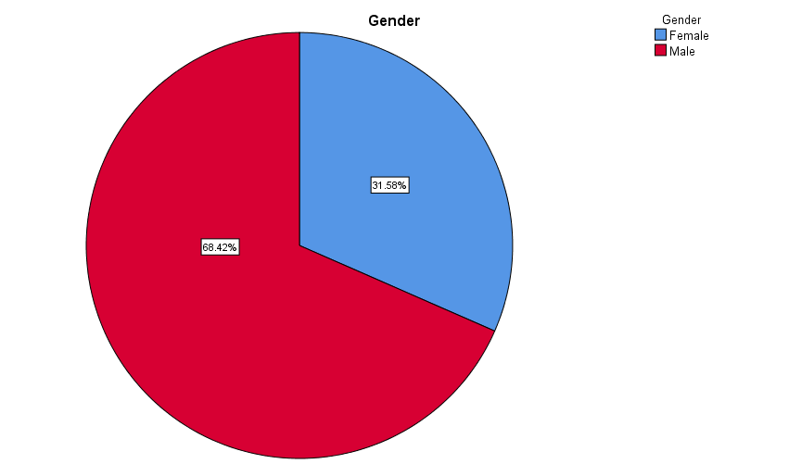
Figure 4.2.1: Gender distribution of Participants

4.2.2 Position/Role of Respondents
Most respondents were teachers (63.2%, n=24), followed by headteachers (15.8%, n=6) and deputy headteachers (7.9%, n=3). Only a small proportion occupied senior administrative roles. This distribution implies that findings largely reflect classroom-level experiences rather than managerial perspectives. Consequently, interpretations are grounded mainly in day-to-day teaching realities rather than policy or strategic decision-making viewpoints.
Table 4.2.1: Position/Role
 |  | Frequency | Percent | Valid Percent | Cumulative Percent
Valid | Deputy Headmaster | 1 | 2.6 | 2.6 | 2.6
Valid | Deputy Headteacher | 3 | 7.9 | 7.9 | 10.5
Valid | Head teacher | 1 | 2.6 | 2.6 | 13.2
Valid | Headteacher | 6 | 15.8 | 15.8 | 28.9
Valid | HOD, Science teacher | 1 | 2.6 | 2.6 | 31.6
Valid | Secondary school teacher/ boarding master | 1 | 2.6 | 2.6 | 34.2
Valid | teacher | 1 | 2.6 | 2.6 | 36.8
Valid | Teacher | 24 | 63.2 | 63.2 | 100.0
Valid | Total | 38 | 100.0 | 100.0

4.2.3 Years of Experience in Education
The majority of respondents had substantial experience, with 42.1% (n=16) having 10–20 years and 21.1% (n=8) having over 21 years in education. This suggests a mature and experienced sample capable of providing informed insights. The relatively small proportion with less than five years’ experience indicates that findings are shaped by seasoned professionals with long-term exposure to the education system.
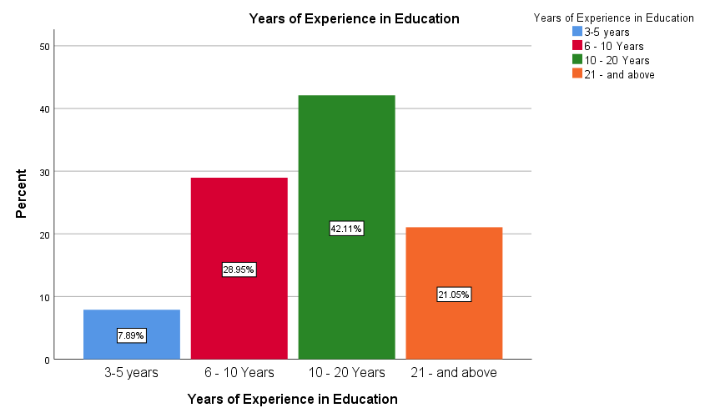
Figure 4.2.2: Respondents' Years of Experience

4.2.4 Type of School
Most respondents were from public schools (73.7%, n=28), while 23.7% (n=9) were from private schools and (2.63% n=1) did not disclose the type of school. This dominance of public-school participants suggests that the findings largely represent public education contexts. As public schools often face different resource, policy, and administrative conditions compared to private institutions, interpretations should be viewed primarily through the lens of the public education system.
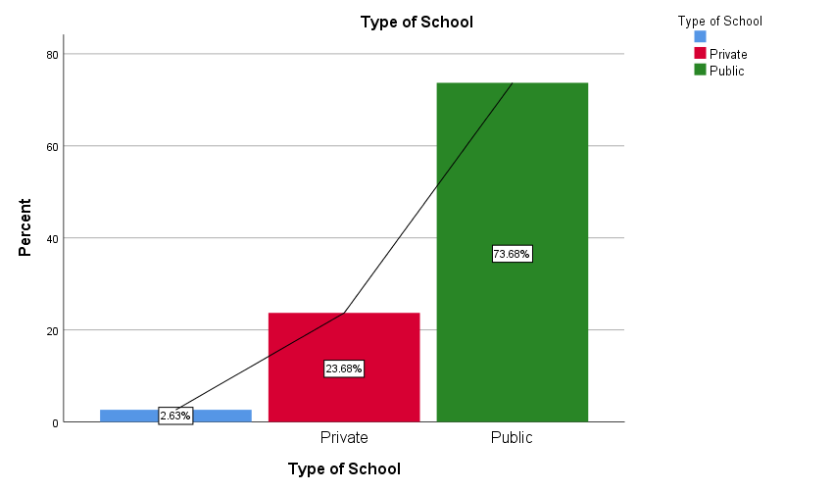
Figure 4.2.3: Type of School

4.2.5 School Location
A greater proportion of respondents were based in rural schools (65.8%, n=25), compared to 34.2% (n=13) from urban areas. This indicates that rural perspectives are more prominent in the study. The findings therefore likely reflect challenges and experiences common in rural educational settings, such as limited resources and accessibility issues, which may differ from urban school environments.
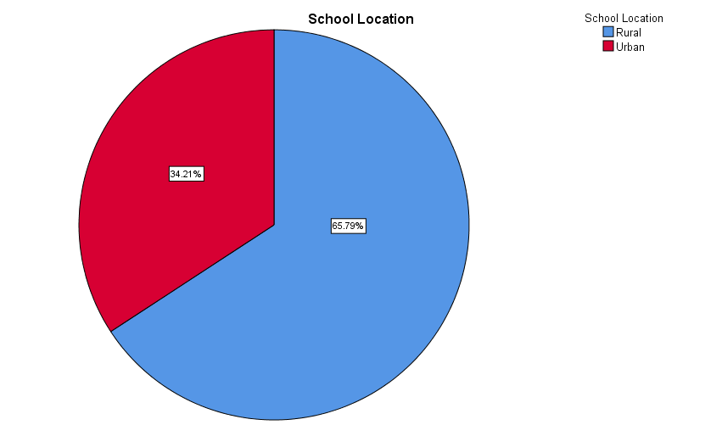
Figure 4.4: Location of Study Participants

4.3 Strategies Used to Prevent Vandalism
Thematic Responses in Table 4.3.2 presents key strategies used to address vandalism in schools. Enforcement of rules and punitive measures emerged as the most cited theme (14 respondents), highlighting reliance on discipline. Counselling and civic education (11) reflect preventive approaches. Strengthening security (9), stakeholder engagement (8), and student participation (7) indicate collaborative and participatory efforts to safeguard school property.
Table 4.3.2 Categorizes the responses and assigns counts to each theme.
Themes | Descriptions | Number of Respondents
Enforcement of rules and punitive measures | disciplinary measures such as punishments, suspensions, expulsions, compensation, and replacement of damaged property to deter vandalism | 14
Counselling, civic education and behaviour change interventions | counselling services, civic education, and behaviour change programmes are used to address the root causes of vandalism and promote positive attitudes among students | 11
Strengthening school security and vigilance | Schools enhance monitoring through security guards, prefects, regular patrols, roll calls, and collaboration | 9
Stakeholder engagement and community participation | Parents, community members, and other stakeholders are actively involved through meetings, guidance, and shared responsibility in safeguarding school infrastructure and resources. | 8
Student ownership, participation and leadership | Students are empowered through leadership roles, student councils, prefect systems, and involvement in school beautification and decision-making, fostering a sense of ownership and responsibility | 7

The findings indicate that schools employ a combination of strategies to prevent vandalism, emphasizing both punitive and preventive approaches. Enforcement of rules and punitive measures was widely reported, with participants noting strict penalties such as expulsions, suspensions, and property replacement the student replaces what he/she breaks. Alongside discipline, counselling and civic education were frequently used to address the root causes of destructive behavior, as one respondent explained, continuous counseling on the dangers of the vice. The findings further highlight the role of security and vigilance, with schools utilizing guards, prefects, patrols, and community monitoring community involvement in monitoring school property.
Additionally, stakeholder and community engagement emerged as a critical strategy, with parents and local communities actively supporting protection of school property frequent meeting with school stakeholders. Finally, schools foster student ownership and leadership by involving students in decision-making, beautification projects, and rule enforcement a vibrant student council which works hand in hand with the administration.

4.2 To assess the challenges educators face in implementing vandalism prevention measures.
The findings indicate that educators face multiple challenges in implementing vandalism prevention measures, with a dominant theme being student resistance and peer influence, as participants reported that students often misinterpret disciplinary measures or succumb to peer pressure Resistance due to peer pressure. Financial and material limitations also constrain schools’ ability to maintain infrastructure or invest in preventive systems Financial constraints.
Furthermore, lack of cooperation from parents and community members was frequently noted, with some parents unwilling to support disciplinary measures or replace damaged property Some parents resist to replace. Time constraints and academic pressures reduce the opportunity for counselling and monitoring, making it difficult for teachers to reinforce responsible behavior Counseling… demands cancellation of a period… thus wasting teaching and learning time. Finally, educators highlighted difficulties in identifying perpetrators and enforcing consequences, especially when vandalism is collective or favoritism influences punishment Vandalism is done by group of students which is not easy to point out the ones who are guilty. The findings reflect that while schools have prevention strategies in place, their effectiveness is hampered by social, resource, and operational challenges, emphasizing the need for holistic approaches that engage students, parents, and communities while providing adequate support and clear enforcement systems.

4.4 To examine educators` perceptions on effective approaches for reducing school vandalism.
The findings indicate that educators perceive a combination of discipline, ownership, community engagement, leadership, and infrastructure investment as key to reducing school vandalism. Many emphasized the importance of consistent and fair enforcement of rules, noting that students respond when consequences are clear and predictable Punishment enable students to avoid vandalize school properties… because they know what will happen next. Equally important is building student ownership and responsibility, with educators highlighting that a sense of pride and accountability over school property fosters self-regulation Learner ownership of learning institutions property. Advocacy works and should continue. Parental and community involvement was seen as critical for sustaining prevention efforts and reinforcing positive normsThe community, parents and teachers work hand in hand to address issues affecting learners. Educators stressed the value of approachable leadership, positive teacher student relationships, and counseling as protective factors that promote a supportive and disciplined environment They should always be close to students and listen carefully to their issues and resolve them positively.
Finally, respondents highlighted the need for structural and technological solutions, such as fences, CCTV cameras, and formal policies, to provide systematic support and accountability Brick fence to all schools to avoid outsiders destroying the properties and blaming students. Collectively, these findings suggest that effective vandalism prevention requires an integrated approach that combines behavioral, relational, community, and infrastructural strategies, emphasizing that policies alone are insufficient without active engagement and practical measures at the school level.

CHAPTER FIVE: DISCUSSION OF RESULTS

5.1 Introduction
This chapter discusses the research findings in relation to the study’s objectives and links them to relevant literature and theoretical frameworks. The study aimed to explore strategies, challenges, and perceptions related to school vandalism in selected Malawian secondary schools. The discussion is structured according to the three research objectives: strategies used to prevent vandalism, challenges educators face in implementing these strategies, and educators’ perceptions of effective approaches for reducing vandalism. The analysis draws on Crime Prevention Through Environmental Design (CPTED), Social Learning Theory, and participatory educational frameworks to interpret how schools and educators influence student behavior and promote responsible stewardship of school property.

5.2 Strategies Used to Prevent Vandalism
The findings indicate that schools employ a combination of punitive, preventive, and participatory strategies to mitigate vandalism. Enforcement of rules and punitive measures was the most frequently reported strategy, including suspensions, expulsions, and property replacement. This reflects patterns documented in Malawi and elsewhere, where disciplinary measures serve as both deterrent and corrective mechanisms (Ministry of Education, 2019; Carter, 2021). Counselling, civic education, and behaviour change interventions were also prominent, demonstrating that educators recognize the need to address the root causes of destructive behavior rather than relying solely on punishment. This aligns with literature emphasizing preventive, restorative approaches and the development of positive school climates (Cohen, 2017; Wilson, 2018).
In addition, schools strengthen security and vigilance through patrols, prefect systems, and community involvement, echoing regional evidence from Sub-Saharan Africa that highlights the role of collective responsibility and surveillance in resource-limited contexts (Banda, 2017; Okonkwo, 2020). Stakeholder engagement and student ownership were equally important. Meetings with parents and communities, involvement in decision-making, and student-led projects foster a sense of responsibility and reinforce social norms against vandalism. These findings suggest that strategies combining discipline, education, and participatory governance are more likely to produce sustained positive outcomes than punitive measures alone.

5.3 Challenges in Implementing Vandalism Prevention Measures
Despite these strategies, educators face multiple challenges in implementation. Student resistance and peer influence were prominent, reflecting social dynamics where misinterpretation of rules or pressure from peers undermines school initiatives. This resonates with Social Learning Theory, which emphasizes that behavior is learned from observation and imitation; if peer norms condone vandalism, prevention efforts are weakened (Wilson, 2018).
Financial and material constraints further limit schools’ ability to maintain infrastructure or invest in preventive systems, consistent with regional research showing that resource limitations hinder effective strategy implementation (Sichone, 2018). Lack of parental and community cooperation, as well as time pressures from the curriculum, emerged as additional barriers. Educators highlighted difficulties in identifying perpetrators and enforcing consequences, particularly when vandalism occurs collectively or favoritism affects discipline. These findings underscore the importance of addressing both structural and relational challenges, confirming that policies alone are insufficient without operational support and community engagement (Musaya, 2022; Kamtengeni, 2021).

5.4 Educators’ Perceptions of Effective Approaches
Educators perceive that effective vandalism prevention requires an integrated approach combining discipline, ownership, community engagement, leadership, and infrastructure investment. Consistent and fair enforcement of rules was considered essential to set clear expectations and deter destructive behavior. Equally important is cultivating student ownership, where involvement in councils, beautification projects, and rule enforcement fosters self-regulation and pride.
Parental and community involvement was consistently highlighted as critical for reinforcing positive norms, reflecting African studies where collaborative governance and cultural authority enhance student accountability (Banda, 2017; Okonkwo, 2020). Educators also emphasized leadership and teacher-student relationships, noting that approachable leadership and supportive interactions help prevent vandalism and promote responsible behavior. Finally, infrastructural and technological solutions, such as fences, CCTV cameras, and formal policies, were seen as necessary to provide systematic support and ensure accountability. Collectively, these findings indicate that effective prevention is multi-dimensional, integrating behavioral, relational, and structural elements rather than relying solely on disciplinary action.

5.5 Conclusion
The discussion confirms that schools in Malawi employ strategies similar to those documented globally and regionally, blending discipline, education, community engagement, and participatory governance. However, implementation is constrained by social, financial, and operational challenges, highlighting a gap between policy intentions and school-level practice. Addressing school vandalism effectively requires a holistic approach that combines clear rules, preventive education, student engagement, parental involvement, and infrastructural support. Integrating these theoretical and practical strategies is essential to cultivate a culture of responsibility, accountability, and stewardship among learners.

CHAPTER SIX: SUMMARY, CONCLUSION, LIMITATIONS, AND RECOMMENDATIONS

6.1 Summary of the Study
This study explored strategies, challenges, and perceptions related to school vandalism in selected Malawian secondary schools, guided by three main objectives: to explore the strategies currently used by schools to prevent vandalism, to assess the challenges educators face in implementing these measures, and to examine educators’ perceptions of effective approaches for reducing vandalism. Data was collected from 39 participants, including teachers, school administrators, and community members. The findings revealed that schools employ a combination of disciplinary, preventive, and participatory strategies, including enforcement of rules, counselling and civic education, security and vigilance measures, stakeholder engagement, and student leadership initiatives. Despite these strategies, educators face challenges such as student resistance, peer influence, financial and material constraints, lack of parental cooperation, time pressures, and difficulties identifying and disciplining perpetrators. Educators also highlighted that effective prevention requires consistent enforcement, fostering student ownership, active parental and community involvement, supportive leadership, and investment in infrastructure and policy frameworks.

6.2 Conclusion
The study concludes that school vandalism persists due to a complex interplay of student behavior, institutional limitations, and socio-cultural factors. While schools implement multiple preventive measures, these strategies are often constrained by limited resources, inconsistent rule enforcement, lack of parental and community engagement, and operational challenges. Educators perceive that fostering student ownership, strengthening community collaboration, and providing structural and policy support are essential to reducing vandalism. Bridging the gap between policy and practice will require integrated approaches that combine disciplinary, preventive, relational, and infrastructural interventions to cultivate responsibility, accountability, and stewardship among learners.

6.3 Limitations of the Study
This study was limited to a small sample of schools and educators, which may not fully represent all secondary schools in Malawi. Additionally, data collection relied on self-reported perspectives, which may be subject to bias or exaggeration. The scope focused on educators and key community stakeholders, excluding students’ views, which also influence the dynamics of school vandalism.

6.4 Recommendations
The following recommendations are made:
  - Schools should ensure that disciplinary measures for vandalism are consistently applied and clearly communicated to all students to enhance deterrence.
  - Learners should be actively engaged in decision-making, school beautification, and leadership initiatives to foster a sense of responsibility for school property.
  - Schools should consider structural measures such as fencing, surveillance systems, and clear institutional policies to provide systematic support and enhance accountability.

6.5 Areas for Further Study
Future research should include student perspectives to gain a comprehensive understanding of the factors driving vandalism. Comparative studies across different districts, school types (urban vs rural), or socio-economic contexts would help identify contextual influences on vandalism behaviors. Additionally, longitudinal studies examining the impact of integrated preventive strategies over time could inform more effective policy and school-level interventions.

References
Ajzen, I. (1991). The theory of planned behavior. Organizational Behavior and Human Decision Processes, 50(2), 179–211. https://doi.org/10.1016/0749-5978(91)90020-T
Ajzen, I. (2020). The theory of planned behavior: Frequently asked questions. Human Behavior and Emerging Technologies, 2(4), 314–324. https://doi.org/10.1002/hbe2.195
Astor, R. A., Meyer, H. A., & Pitner, R. O. (2010). Elementary and middle school counseling: Foundations and practices. Pearson Education. https://www.pearson.com
Banda, F. (2017). Community participation in school governance: A study of school management committees in Malawi (Unpublished master’s thesis). University of Malawi. https://www.unima.ac.mw
BERA. (2018). Ethical guidelines for educational research (4th ed.). British Educational Research Association. https://www.bera.ac.uk/publication/ethical-guidelines-for-educational-research-2018
Braun, V., & Clarke, V. (2022). Thematic analysis: A practical guide. SAGE Publications. https://uk.sagepub.com/en-gb/eur/thematic-analysis/book248481
Bronfenbrenner, U., & Morris, P. A. (2006). The bioecological model of human development. In W. Damon & R. M. Lerner (Eds.), Handbook of child psychology (6th ed., Vol. 1, pp. 793–828). John Wiley & Sons. https://onlinelibrary.wiley.com
Carter, M. (2021). Crime prevention through environmental design (CPTED) in schools: A review of the literature. National Institute of Justice. https://nij.ojp.gov
Chile, J., & Black, X. Y. (2020). Qualitative research delimitations: Considerations for design and reporting. International Journal of Qualitative Methods, 19, 1–10. https://doi.org/10.1177/1609406920937971
Chirwa, G. (2019). Incidents of school vandalism and arson in Mchinji District. Ministry of Education, Malawi. https://www.education.gov.mw
Cohen, J. (2017). School climate and vandalism. Educational Leadership, 74(8), 52–57. https://www.ascd.org
Dupper, D. R. (2010). A new model of school discipline: Engaging students and preventing behavior problems. Oxford University Press. https://global.oup.com
Kadzakumanja, J. (2022). Practical strategies for preventing school vandalism in Malawi: A case study of peer monitoring. University of Malawi. https://www.unima.ac.mw
Kamtengeni, J. (2021). Challenges faced by educators in managing student discipline in Malawian secondary schools. University of Malawi. https://www.unima.ac.mw
Kaunda, Z. (2020). The missing voice: Educators’ perspectives in school safety research in Malawi. Malawi Journal of Education, 15(2), 45–60. https://www.mje.mw
Maphosa, C., & Bhebhe, S. (2019). School discipline and learner alienation in Zimbabwean schools. Africa Education Review, 16(3), 112–126. https://doi.org/10.1080/18146627.2018.1468489
Ministry of Education, Malawi. (2019). Report on the Kamwanya CDSS fire incident and recommendations. https://www.education.gov.mw
Musaya, A. (2022). Socio-economic influences on youth delinquency and school vandalism in Malawi. University of Malawi Press. https://www.unima.ac.mw
Mutiso, R., & Njoroge, G. (2018). Student alienation and participation in school vandalism in Kenyan secondary schools. Journal of Education and Practice, 9(15), 78–85. https://files.eric.ed.gov/fulltext/EJ1181997.pdf
Mwale, J. (2019). Community-school relationships and collaborative vandalism prevention in Malawi. Chancellor College. https://www.unima.ac.mw
Nemlioğlu, K., & Atak, H. (2010). The relationship between students’ sense of school belonging and vandalism. International Journal of Human Sciences, 7(2), 654–668. https://www.j-humansciences.com
Nowell, L. S., Norris, J. M., White, D. E., & Moules, N. J. (2017). Thematic analysis: Striving to meet the trustworthiness criteria. International Journal of Qualitative Methods, 16(1), 1–13. https://doi.org/10.1177/1609406917733847
Okonkwo, C. (2020). The role of traditional and religious leaders in promoting school safety in West Africa. African Educational Research Network. https://aernetwork.org
Phiri, F., & Banda, D. (2017). The financial and educational impact of school vandalism in Malawi. Journal of Educational Development, 35(4), 512–525. https://doi.org/10.1016/j.ijedudev.2017.04.003
Scotland, J. (2012). Exploring the philosophical underpinnings of research. English Language Teaching, 5(9), 9–16. https://doi.org/10.5539/elt.v5n9p9
Sichone, B. (2018). Funding and maintenance challenges in Zambian schools. University of Zambia Press. https://www.unza.zm
Smith, J., & Jones, A. (2019). The cost of security: Financial trade-offs in school safety measures. International Journal of Educational Management, 33(5), 1020–1035. https://doi.org/10.1108/IJEM-01-2018-0021
Van Niekerk, M. (2016). Institutional support systems for school safety in South Africa. HSRC Press. https://www.hsrcpress.ac.za
Wilson, D. B. (2018). Restorative practices in schools: Research reveals power of relationship-building. International Institute for Restorative Practices. https://www.iirp.edu
Yin, R. K. (2018). Case study research and applications: Design and methods (6th ed.). SAGE Publications. https://us.sagepub.com

